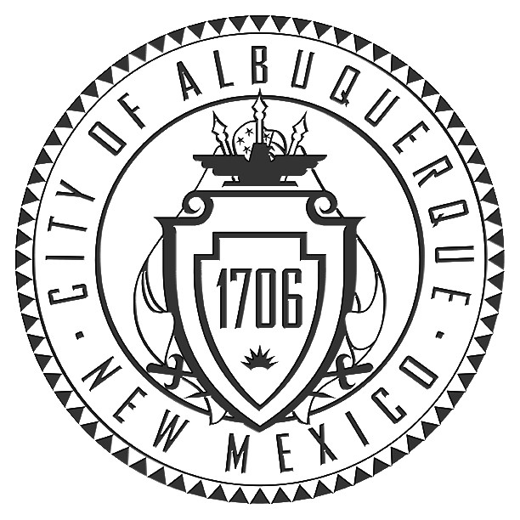

ENVIRONMENTAL PLANNING COMMISSION
ACTION SUMMARY

Thursday, December 16, 2021
8:40 a.m.

Due to COVID-19 this meeting is a Public Zoom Video Conference

Members of the public may attend via the web at this address: https://cabq.zoom.us/j/2269592859 or by calling the following number: 1 301 715 8592 and entering Meeting ID: 226 959 2859
COMMISSIONER MEMBERS PRESENT:
Tim MacEachen, Chair
David Shaffer, Vice Chair
Dennis F. Armijo, Sr
Robert Stetson
Gary L. Eyster, P.E. (Ret.)
Joseph Cruz
Richard Meadows
Jonathan R. Hollinger

Call to Order: 8:50 am
- Pledge of Allegiance
- Roll Call of Planning Commissioners
- Suspension of the Rules- Article I, Section IV of the EPC Rules of Practice & Procedure

A motion was made by Commissioner Eyster, and Seconded by Commissioner Stetson,
that this matter be approved. The motion carried by the following vote:

For 8: – Eyster, Cruz, Meadows, Stetson, Hollinger, Shaffer, MacEachen, & Armijo

- Zoom Overview
- Announcement of Changes and/or Additions to the Agenda
- Approval of Amended Agenda
- Swearing in of City Staff

1. Project #2021-006202  RZ-2021-00050– Zoning Map Amendment (Zone Change) | A.G. Services, agent for Robert Gutierrez, requests a zoning map amendment from PD to R-A for all or a portion of Lot B, plat of El Jaral Subdivision together with Tract 303-A MRGCD Map #35, located on Montoya Rd. NW, between Maximillian Rd. NW and Interstate-40, approximately 4.6 acres (H-12-Z)  Staff Planner: Leroy Duarte  A motion was made by Commissioner Eyster, and Seconded by Commissioner Shaffer, that this matter be Deferred for 60 days to the February 17, 2022 hearing. The motion carried by the following vote:  For 6: – Eyster, Cruz, Meadows, Shaffer, MacEachen, & Armijo  Commissioner Stetson/Hollinger had technical issues.
2. Project# 2018-001843  RZ-2021-00049 – Text Amendments to Integrated Development Ordinance (IDO)—Small Areas | The City of Albuquerque Planning Department requests the above action to amend the text of the Integrated Development Ordinance (IDO). This third annual update includes changes requested by neighbors, developers, staff, and Council Services to the standards applicable to one small area: Old Town HPO-5 (J-13-Z). Applies to all properties within Old Town – HPO-5.  Staff Planner: Silvia Bolivar  More information is available online at: https://abc-zone.com/ido-annual-update-2021  A motion was made by Commissioner Armijo, and Seconded by Commissioner Stetson, that this matter be be forwarded to City Council with a recommendation of Approval. The motion carried by the following vote:  For 8: – Eyster, Cruz, Meadows, Stetson, Hollinger, Shaffer, MacEachen, & Armijo
3. Project# 2018-001843  RZ-2021-00048 – Text Amendments to Integrated Development Ordinance (IDO)—City-wide | The City of Albuquerque Planning Department requests the above action to amend the text of the Integrated Development Ordinance (IDO). This third annual update includes approximately 73 changes requested by neighbors, developers, staff, and Council Services. City-wide.  Staff Planners: Catalina Lehner and Sergio Lozoya  More information is available online at: https://abc-zone.com/ido-annual-update-2021  A motion was made by Commissioner Hollinger, and Seconded by Commissioner Eyster, that this matter be be forwarded to City Council with a recommendation of Approval. The motion carried by the following vote:  For 8: – Eyster, Cruz, Meadows, Stetson, Hollinger, Shaffer, MacEachen, & Armijo

4. OTHER MATTERS:
Approval of November 18, 2021 Action Summary Minutes
A motion was made by Commissioner Hollinger, and Seconded by Commissioner Eyster,
that this matter be approved. The motion carried by the following vote:

For 8: – Eyster, Cruz, Meadows, Stetson, Hollinger, Shaffer, MacEachen, & Armijo

5. ADJOURNMENT 4:12 pm

